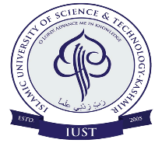**Department of Environment Sustainability and Climate Change**

ISLAMIC UNIVERSITY OF SCIENCE & TECHNOLOGY

AWANTIPORA -192122, KASHMIR

Dr. Sumira Nazir Zaz

Coordinator

Email: zaz.sumira@gmail.com

Dated: 07-01-2020

No. IUST/DESCC/RS/1/07/15

Dated: 21st July 2024

March, 2024

Dated: 07-01-2020

This is to inform to all faculty members that a Departmental Committee (DC) meeting has been scheduled for 22th July at 3:30 PM to discuss the agendas for the upcoming DRC.

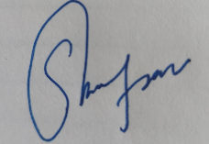

Coordinator.